HSE Monthly Report – February 2026
Weyland Energy – all sites
Hannah Weber · 08 March 2026 · HSE-RPT-2026-02

1. Headlines
The T-07 gearbox exchange at Kestrel Ridge (750 t crawler crane, snow on site) was completed without incident on 2–5 February. One medical treatment case at Uckermark Solar (cut to hand).
Indicator | February | YTD 2026 | 2025
Hours worked | 128,000 | 254,000 | 1,452,000
Lost time injuries | 0 | 0 | 2
Recordable injuries | 1 | 1 | 6
First aid cases | 5 | 10 | –
Near misses | 28 | 56 | 307
Safety observations | 226 | – | –
LTIFR rolling 12 months | 1.35 | – | 1.38
TRIR rolling 12 months | 4.73 | – | 4.13

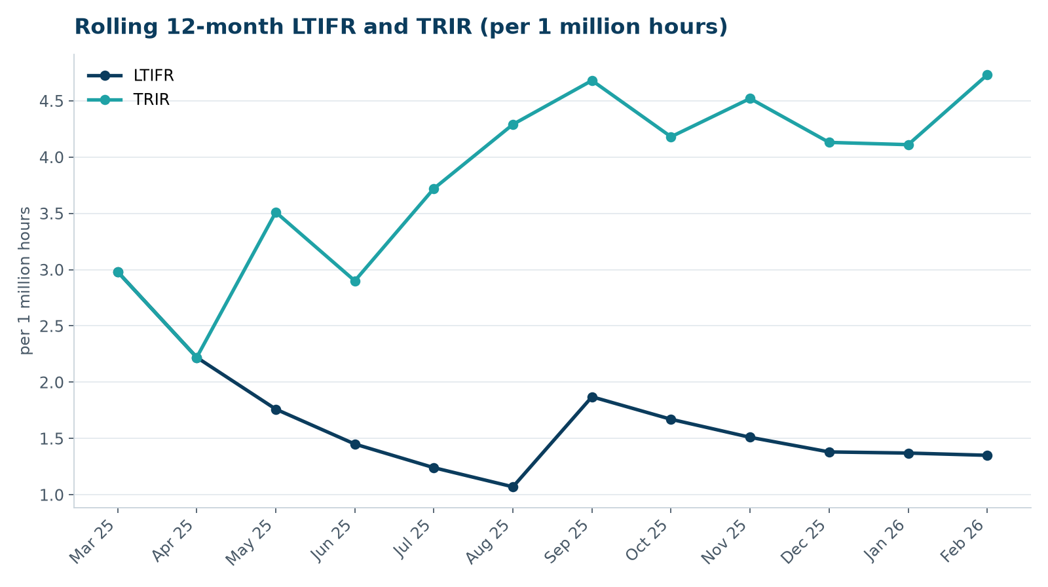

2. Hours by group
Group | Hours | Share
Weyland employees | 62,000 | 48 %
O&M contractors (operating assets) | 35,000 | 27 %
Harrow Bay contractors | 31,000 | 24 %

3. Leading indicators
- Toolbox talks delivered: 100
- Management safety walks: 9 (target 12)
- Inspections of lifting equipment: 40
- Open corrective actions older than 30 days: 12

4. Focus for next month
Heat stress awareness for nacelle work and solar park maintenance during summer.
Hannah Weber, HSE Manager

